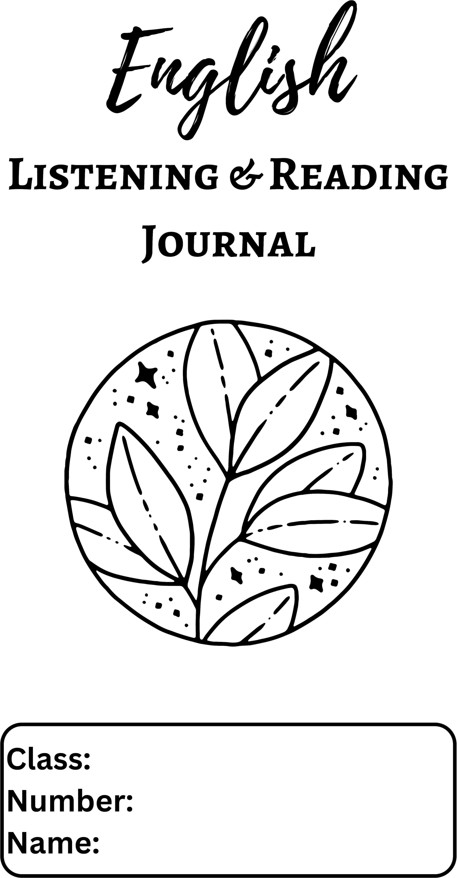


Clip Title:
I. Please take notes while you are listening. (Key words only.)

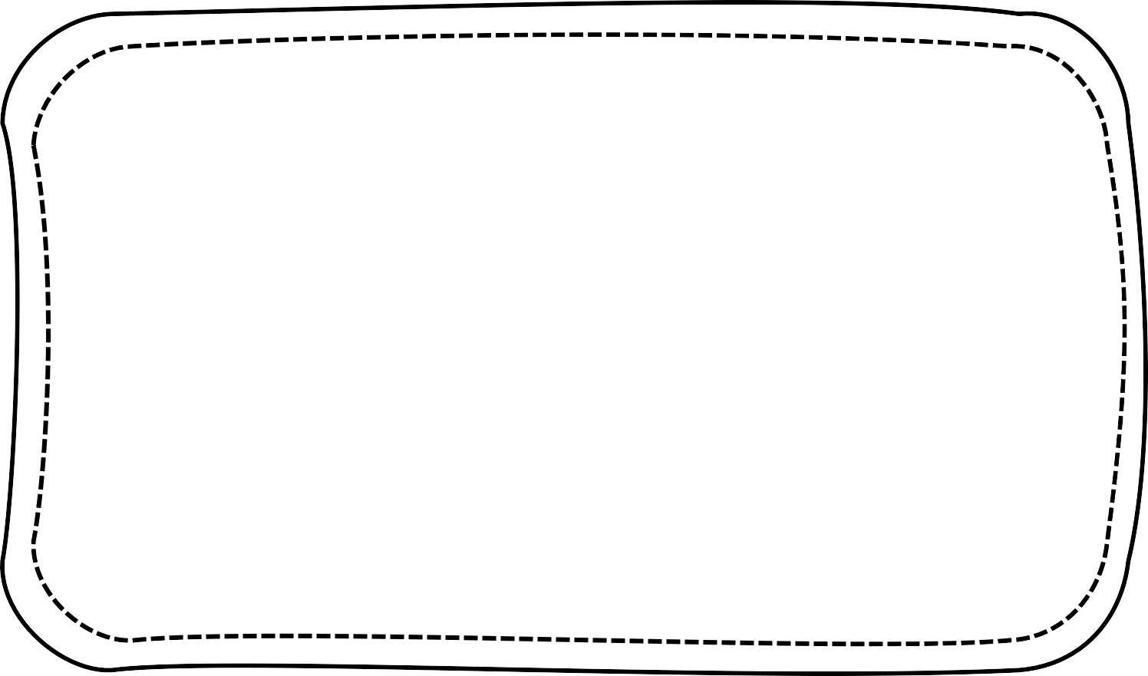

II. Please organize the above notes into a 6-sentence summary.

1. | 2.
3. | 4.
5. | 6.
7. | 8.
9. | 10.

IV. Please state what you think about the content and whether you agree with its idea or not. (You may use the following expressions for your thoughts.)

Useful Expressions
‧I totally/partly agree with it because….
‧In my opinion, it’s only partly true that….

‧To tell the truth, I don’t think….
‧As far as I’m concerned, ….
‧I’m afraid I disagree with it because….
‧I wonder if ….

Clip Title:
I. Please take notes while you are listening. (Key words only.)


II. Please organize the above notes into a 6-sentence summary.

1. | 2.
3. | 4.
5. | 6.
7. | 8.
9. | 10.

IV. Please state what you think about the content and whether you agree with its idea or not. (You may use the following expressions for your thoughts.)
Useful Expressions
‧I totally/partly agree with it because….
‧In my opinion, it’s only partly true that….
‧To tell the truth, I don’t think….
‧As far as I’m concerned, ….
‧I’m afraid I disagree with it because….
‧I wonder if ….

Clip Title:
I. Please take notes while you are listening. (Key words only.)

II. Please organize the above notes into a 6-sentence summary.

1. | 2.
3. | 4.
5. | 6.
7. | 8.
9. | 10.

IV. Please state what you think about the content and whether you agree with its idea or not. (You may use the following expressions for your thoughts.)
Useful Expressions
‧I totally/partly agree with it because….
‧In my opinion, it’s only partly true that….
‧To tell the truth, I don’t think….
‧As far as I’m concerned, ….
‧I’m afraid I disagree with it because….
‧I wonder if ….

Clip Title:
I. Please take notes while you are listening. (Key words only.)


II. Please organize the above notes into a 6-sentence summary.

1. | 2.
3. | 4.
5. | 6.
7. | 8.
9. | 10.

IV. Please state what you think about the content and whether you agree with its idea or not. (You may use the following expressions for your thoughts.)
Useful Expressions
‧I totally/partly agree with it because….
‧In my opinion, it’s only partly true that….
‧To tell the truth, I don’t think….
‧As far as I’m concerned, ….
‧I’m afraid I disagree with it because….
‧I wonder if ….


Who?
When?
Where?
What happened?
Why?
How did it
happen?

- Words You’ve Learned
Please list three words you’ve learned from the story and make a sentence with each new word. (* You CANNOT copy the example sentences from the lesson.)
  - In your opinion, what is the most interesting plot of the story?

  - What message does the story try to convey?

  - Do you like the story? Why or why not?

Who?
When?
Where?
What happened?
Why?
How did it
happen?
- Words You’ve Learned
Please list three words you’ve learned from the story and make a sentence with each new word. (* You CANNOT copy the example sentences from the lesson.)
  - In your opinion, what is the most interesting plot of the story?

  - What message does the story try to convey?

  - Do you like the story? Why or why not?

Who?
When?
Where?
What happened?
Why?
How did it
happen?
- Words You’ve Learned
Please list three words you’ve learned from the story and make a sentence with each new word. (* You CANNOT copy the example sentences from the lesson.)
  - In your opinion, what is the most interesting plot of the story?

  - What message does the story try to convey?

  - Do you like the story? Why or why not?

Who?
When?
Where?
What happened?
Why?
How did it
happen?
- Words You’ve Learned
Please list three words you’ve learned from the story and make a sentence with each new word. (* You CANNOT copy the example sentences from the lesson.)
  - In your opinion, what is the most interesting plot of the story?

  - What message does the story try to convey?

  - Do you like the story? Why or why not?

